14.10.2021 Учебная группа 2ТЭМ, 1-я пара

Преподаватель Иванова Наталия Викторовна
ОГСЭ.03 Иностранный язык (английский)

Тема: Соединенное Королевство Великобритании и Северной Ирландии. Present Indefinite Tense.
Цель занятия:
образовательная: изучение грамматического материала, развитие монологических умений по теме “ Соединенное Королевство Великобритании и Северной Ирландии”; совершенствование умений информативного чтения с извлечением специальной информации,
развивающая: развитие способности логически правильно и грамотно излагать свои мысли по теме; развитие способности анализировать предъявленный материал, выражать свое мнение по предложенной теме; развитие творческих способностей и эстетического вкуса.
воспитательная: воспитание уважения к культурному наследию Соединенного Королевства Великобритании и Северной Ирландии.
Задачи занятия: увеличение объема знаний страноведческого характера в рамках предъявленной темы.
Мотивация: Today we are going to make our trip to one of the most wonderful and unique countries in the world, the country with a rich history, the country of beautiful landscapes and lake districts, the country consists of four parts. The name of this country is The United Kingdom of Great Britain and Northern Ireland!
Задание студентам:

- Посмотреть видео ресурс https://resh.edu.ru/subject/lesson/6703/main/231773/
- Познакомиться Present Indefinite Tense https://englex.ru/ways-to-express-the-present-in-english/
- Ответить на вопросы по тексту Соединенное Королевство Великобритании и Северной Ирландии
- Выполнить 5 заданий в тетради.

Фотографию с выполненным заданием прислать на электронный адрес atata17@yandex.ru в срок до 08.00 15.10.2021 г.

План:
- Аудирование. Страноведческий материал.
- Чтение и перевод. Изучение грамматики

Работа с заданиями.
Литература:
- Буренина JI.C. Учебник английского языка. - М.: Высшая школа, 1978. - 127 экз.
- Парахина А.С. Учебник английского языка. - М.: Высшая школа, 1987. - 55 экз.

Задание 1 Ответить на вопросы в тетради используя текст

ТЕМА "ВЕЛИКОБРИТАНИЯ" (GREAT BRITAIN)
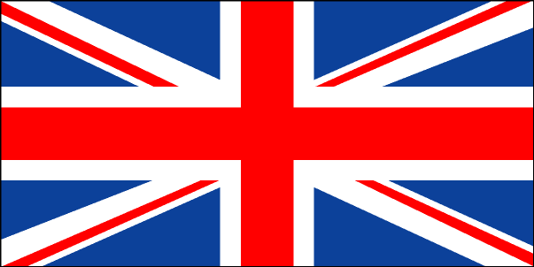
The United Kingdom of Great Britain and Northern Ireland (the UK) occupies the British Isles and consists of 4 parts: England, Wales, Scotland and Northern Ireland. The country has the population of 60 million people within the land area of 244 thousand square kilometers. The isles are washed by the Atlantic Ocean in the north and in the west and by the English Channel in the south. The UK is separated from continental Europe by the North Sea. Great Britain is separated from Northern Ireland by the Irish Sea and the North Channel.
There are many beautiful lakes and mountains in Scotland and England. The highest point in the Highlands is Ben Nevis (1 340 metres). The longest river flows in England, it is the Severn. The main attraction in the north of England is the Lake District. Thanks to the warm waters of Gulf Stream the island is very green and the British climate is mild. Local summers are rather hot and winters are not cold. As the weather is very changeable in Britain, it is the favourite topic for discussion with the British.
The capital of Great Britain is London. It stands on the Thames river. The country is a constitutional monarchy and officially the Queen is the Head of state. But it is ruled by the Prime Minister and the government. The legislative body is the Parliament which consists of the House of Lords and the House of Commons.
The UK is a highly developed industrial state. The chief industries are shipbuilding, fishing and mining, production of aircraft equipment, electronics, textile and chemicals. The country is the world’s largest exporter of iron and steel goods. The most important industrial cities of Great Britain are London, Birmingham, Manchester, Glasgow, Liverpool, Leeds, Edinburgh.
A lot of famous people were born and lived in Great Britain. Among them are Shakespeare, Newton, Churchill, Paul McCartney, Joanne Rowling, Sting, David Beckham and many others.
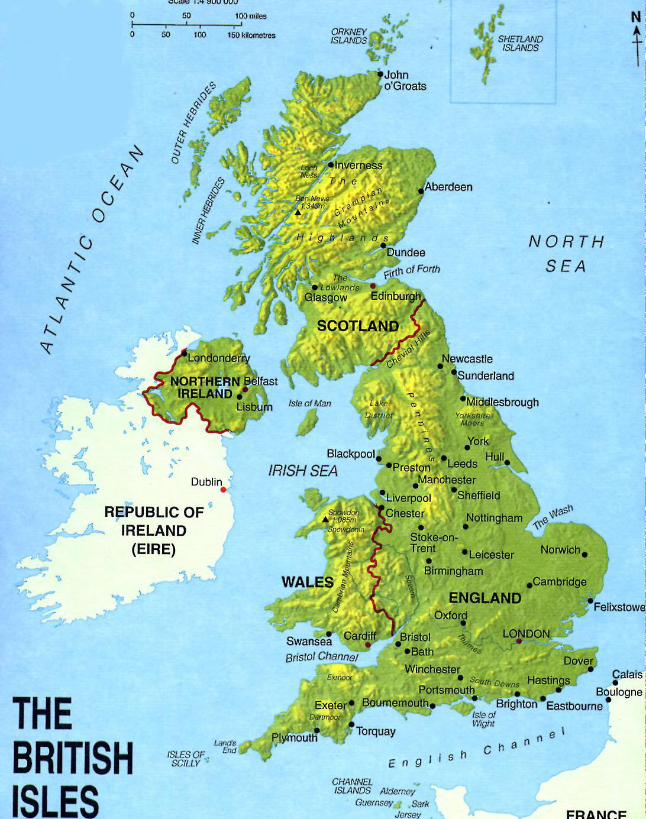
Вопросы к тексту
- What parts does the United Kingdom of Great Britain and Northern Ireland consist of? Name them
- What washes the United Kingdom of Great Britain and Northern Ireland?
- What is the name of the highest point in the highlands?
- What is the name of the longest river that flows in England?
- What is the main attraction of the North of England?
- What is the climate in Britain?
- What is the constitutional system in the UK?
- Who is officially considered the head of state?
- Who runs the UK?
- List the main industries in the UK
- List the main industrial cities in the UK
- List famous people who were born and lived in the UK

Задание 2 Составить свой диалог, используя для примера образец
A: Is England the name of that country?
B: No, it isn't. It's called Great Britain, or simply Britain. England is a part of it.
A: Really? So, I'm sorry, I'm mistaken.
B: In my opinion you simply mix the names.
A: And what about the United Kingdom of Great Britain and Northern Ireland or the United Kingdom? That sounds more official, doesn't it?
B: Yes, it's the official name of that country. But you shouldn't forget that though in everyday speech Britain is used to mean the United Kingdom, it's the name of the island which is made up of England, Scotland and Wales.
A: Thanks, I've guessed at last.
Задание 3 Choose the necessary words from the box and put them in the sentences below:
Roman town, to stay alive, night clubs, the West End, ports, to be full of, office buildings, cities, pubs, the East End, suburbs, restaurants, the Tower of London.
1. London is one of the most important … and one of the largest … in the world.
2. One of the most famous of ancient buildings is … .
3. Once London was a small … on the north bank of the Thames.
4. … is a rich man's world of shops, offices and theatres.
5. … is the district where mostly working people live.
6. There are now new … in Docklands.
7. The West End …, because this is where Londoners come to enjoy themselves.
8. In nearby Soho the …, … and … are busy half the night.
9. London also has many big parks, … trees, flowers and grass.
10. Many people live outside the centre of London in the … .
Задание 4. Are the following sentences true or false? Give your arguments.
1. London is the capital of the United States.
2. London has a population of about 11 million people.
3. London is one of the largest city in the world.
4. Most visitors want to see the Houses of Parliament and Buckingham Palace.
5. Once London was a small Roman town on the north bank of the Mississippi.
6. The City of London isn’t the district where most offices and banks are concentrated.
7. The new port area is now called “Docklands”.
8. London has only streets and concrete buildings.
9. There are two opera houses, several concert halls and many theatres in the East End.
10. Many people live outside the centre of London in the suburbs, and they travel to work in shops and offices by cars.

Задание 5. Поставьте глагол в правильную форму Present Simple
1. What (be) your name? - My name (be) Ann. - Как тебя зовут? - Меня зовут Анна.
2. Where (be) you from? - I (be) from America. - Откуда ты? - Я из Америки.
3. He (work) in an office. - Он работает в офисе.
4. They (live) in a big city. - Они живут в большом городе.
5. Students often (go) to the library. - Студенты часто ходят в библиотеку.
6. We never (miss) classes. - Мы никогда не пропускаем уроки.
7. She (not have) an umbrella. - У нее нет зонта.
8. It sometimes (rain) here. - Иногда здесь идет дождь.
9. I (start) my working day at 10 am. - Я начинаю рабочий день в 10 утра.
10. In the evening Tom (watch) TV and (play) computer games. - Вечером Том смотрит телевизор и играет в компьютерные игры.
11. Water (boil) at 100 degrees C. - Вода кипит при 100 градусах Цельсия.
12. Mary (not smile) to strangers. - Мари не улыбается незнакомцам.
13. I (not understand) this word. - Я не понимаю это слово.
14. Every year she (travel) abroad. - Каждый год она путешествует за границу.
15. He (go) to school by bus. - Он ездит в школу на автобусе.

